Weekly Report

On

“Restaurant Management System”

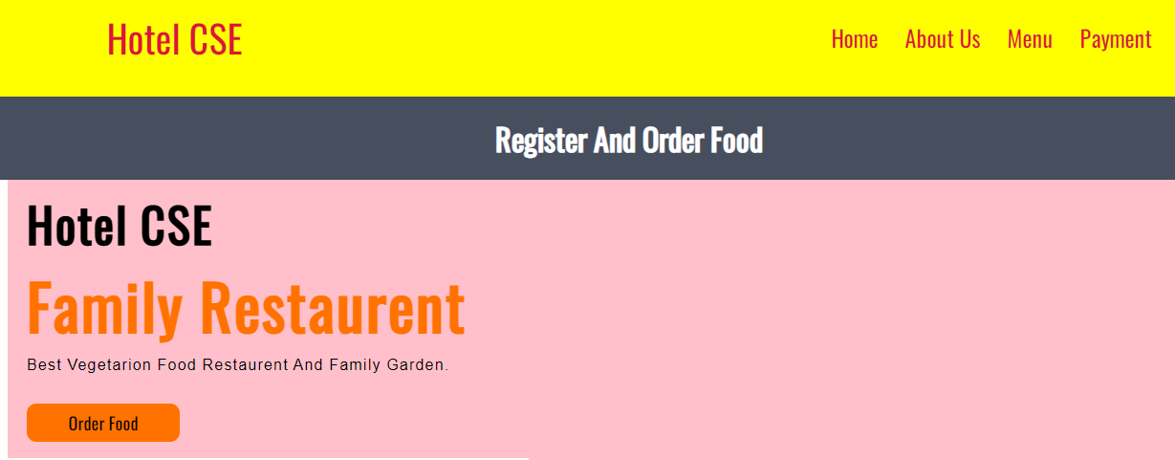

Prepared

By

Manasi Ashok Kamble

(STU61161ca57c8c01628839077)

Department of Computer Engineering

CHH. SHAHU COLLAGE OF ENGINEERING

Dr.Babasaheb Ambedkar Technological University

November 2022

**Week 1**

**Problem Statement:**

Restaurant management systembasically runs between customers and management in a restaurant. the customer interacts with generally one waiter and places their order, while the waiter takes multiple customers in a day. the customer places an order with the waiter, the waiter generates an invoice with the details of the customer, their order and table number, which is sent to the kitchen. once the order is prepared the runner uses the invoice to serve the food. the waiter usually asks again if the customers want to order anything more, this process can go on till the customer decides he does not want any more food. all the invoices generated by the customer are part of a much larger entity called order. the order is essentially the bill generated in the end by the restaurant for the customer.

Now we know the customer, waiter and invoice will be present in the order table. the relationship between customer and order is one to one. the relationship between the waiter and order is one to many. the relationship between invoice and order is one to many.

**Background of the Problem:**

The Restaurant Management System helps the restaurant manager to manage the restaurant more effectively and efficiently by computerizing meal ordering, billing and inventory control.

Restaurant manages the easily.

**User / Customer:**

**A Guide to Winning and Retaining Clients.**

1. Guide Customer to use our online app/website for ordering food.
2. Register and order food.
3. Respect Your Client's Time.
4. Maintain Positive Relations.
5. Educate Your Clients.
6. Make an Employee Act as an Advocate for the Client.
7. Learn to Manage Time.
8. Learn Their Communication Patterns.
9. Involve the Client in the Process.
10. Understand Their Needs.

**Week 2**

**Proposed Solution:**

Our system is a type of restaurant management software intended to assist with the tasks associated with the day-to-day management of a restaurant or similar business. In this article, you can learn about what the technology does, the main features, and the different components that make up a sound system of this kind.

Restaurant management refers to the process of managing day-to-day operations within a restaurant or similar setting. It encompasses a broad range of tasks and responsibilities, from overseeing company finances and facilitating business growth to overseeing marketing, managing the workforce, and delivering a great customer experience, a restaurant manager’s job is to balance the various needs of the business, provide leadership, set strategic objectives, make use of restaurant management software, and ensure all departments are functioning as they should. Ultimately, restaurant management is concerned with guiding a restaurant to long-term success. Many of the benefits associated with the use of restaurant management systems are related to automation and speeding up processes to improve the customer experience. Modern customers expect fast, frictionless service and restaurant management software play a key role in meeting these expectations.

**Restaurant Management Systems and the Restaurant Industry:** The best restaurant management software has to be versatile and customizable because the restaurant industry is so varied and complex. After all, it comprises many different types of restaurants, from fast food and casual restaurants to fine dining experiences, and within each category, there can also be significant variation.

**SERVER:** XAMPP is an abbreviation where **X stands for Cross-Platform, A stands for Apache, M stands for**[**MYSQL**](https://www.javatpoint.com/mysql-tutorial)**, and the Ps stand for PHP and Perl**, respectively. It is an open-source package of web solutions that includes Apache distribution for many servers and command-line executables along with modules such as Apache server, [MariaDB](https://www.javatpoint.com/mariadb-tutorial), PHP, and Perl.

XAMPP helps a local host or server to test its website and clients via computers and laptops before releasing it to the main server. It is a platform that furnishes a suitable environment to test and verify the working of projects based on Apache, Perl, MySQL database, and PHP through the system of the host itself. Among these technologies, [Perl](https://www.javatpoint.com/perl-tutorial) is a programming language used for web development, [PHP](https://www.javatpoint.com/php-tutorial) is a backend scripting language, and MariaDB is the most vividly used database developed by MySQL. The detailed description of these components is given below.

**BACKEND:** PHP started out as a small open-source project that evolved as more and more people found out how useful it was. Rasmus Lerdorf unleashed the first version of PHP way back in 1994.

* PHP is a recursive acronym for "PHP: Hypertext Preprocessor".
* PHP is a server-side scripting language that is embedded in HTML. It is used to manage dynamic content, databases, session tracking, even build entire e-commerce sites.
* It is integrated with a number of popular databases, including MySQL, PostgreSQL, Oracle, Sybase, Informix, and Microsoft SQL Server.
* PHP is pleasingly zippy in its execution, especially when compiled as an Apache module on the Unix side. The MySQL server, once started, executes even very complex queries with huge result sets in record-setting time.
* PHP supports a large number of major protocols such as POP3, IMAP, and LDAP. PHP4 added support for Java and distributed object architectures (COM and CORBA), making n-tier development a possibility for the first time.
* PHP is forgiving: PHP language tries to be as forgiving as possible.
* PHP Syntax is C-Like.

**DATABASE:** [MySQL](https://www.geeksforgeeks.org/structured-query-language/) is an open-source relational database management system (RDBMS). It is the most popular database system used with PHP. MySQL is developed, distributed, and supported by Oracle Corporation.

* The data in a MySQL database are stored in tables which consists of columns and rows.
* MySQL is a database system that runs on a server.
* MySQL is ideal for both small and large applications.
* MySQL is very fast, reliable, and easy to use database system. It uses standard SQL
* MySQL compiles on a number of platforms.

**Example of Existing Solution:**

## 1. [Marie Catribs](http://www.mariecatribs.com/)

## 2. [Olive Garden](http://www.olivegarden.com/home)

## 3. [Veda](http://vedatakeout.com/)

## 4. [Ruby Tuesday](https://www.rubytuesday.com/)

## 5. [MaxBrenner](http://maxbrenner.com/)

## 6. [McDonalds](http://www.mcdonalds.com/us/en/home.html)

**Week 3**

**Diagrams:**

**1)Use-Case Diagram for Online Restaurant Management System**

A use case diagram at its simplest is a representation of a user’s interaction with the system and depicting the specifications of a use case. A use case diagram can portray the different types of a system and the various ways that they interact with the system.

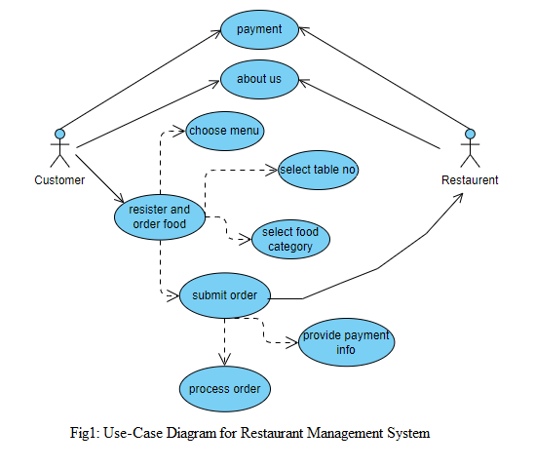

A customer can interact with restaurant through Restaurant Management System.

**2)Class diagram of Restaurant Management System**

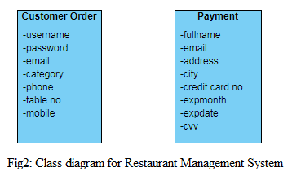

**3)E-R Diagram for Restaurant Management System**

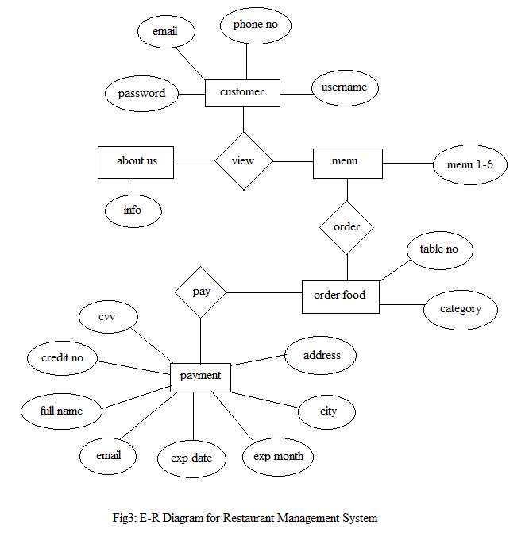

**Timeline Chart (Gantt Chart):**

|  |  |  |  |  |  |  |
| --- | --- | --- | --- | --- | --- | --- |
| **Restaurant Management System Gantt Chart** | | | | | | |
|  |  |  |  |  |  |  |
| **Sr.No** | **Task Name** | **Start Date** | **End Date** | **Duration** | **Progress** | **Status** |
| 1 | Concept Planning | 19-09-22 | 26-09-22 | 2 | 100% | Completed |
| 2 | Designing | 26-09-22 | 01-10-22 | 3 | 100% | Completed |
| 3 | Modeling | 08-10-22 | 13-10-22 | 4 | 96% | Completed |
| 4 | Development | 13-10-22 | 25-10-22 | 5 | 90% | Ongoing |
| 5 | Testing | 25-10-22 | 29-10-22 | 1 | 88% | Ongoing |
| 6 | Deploy/Maintenance | 29-10-22 | 06-11-22 | 5 | 80% | Upcoming |

**Week 4**

1) <https://github.com/SOHAMRS/RestaurantMgtSystem>

2) <https://github.com/SOHAMRS/RestaurantMgtSystem.git>